Supplemental data
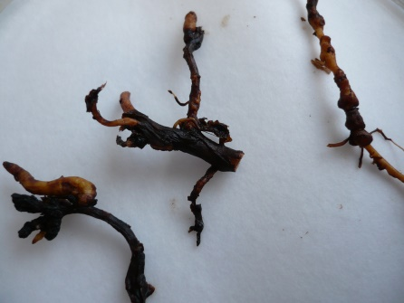
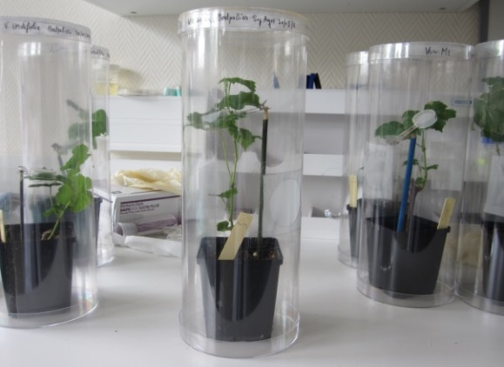
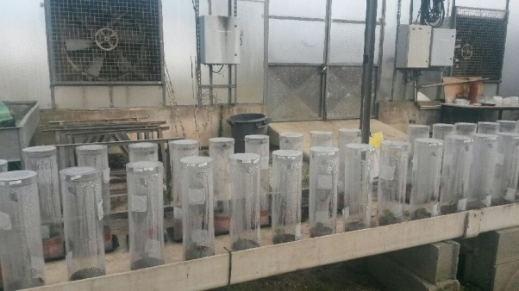
Fig. S1 “In planta” experiment (A) illustration of the experimental device with each plant grown in an individual pot covered by a transparent plastic bell and (B) example of nodosities developed on roots (red arrows)
A
B

Table S2 Characteristics of the experiments in response to X. index carried out over five independent years
RF: reproduction factor, GI: gall index, RW: root weight, RD: root development, R/S: resistance vs. susceptible qualitative phenotyping
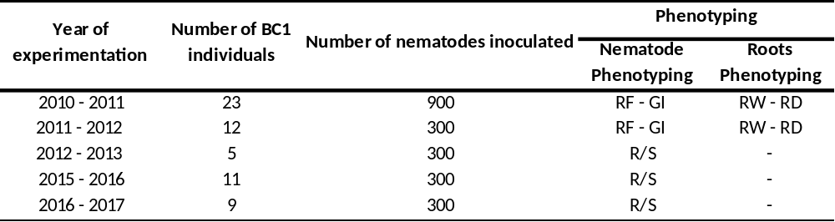

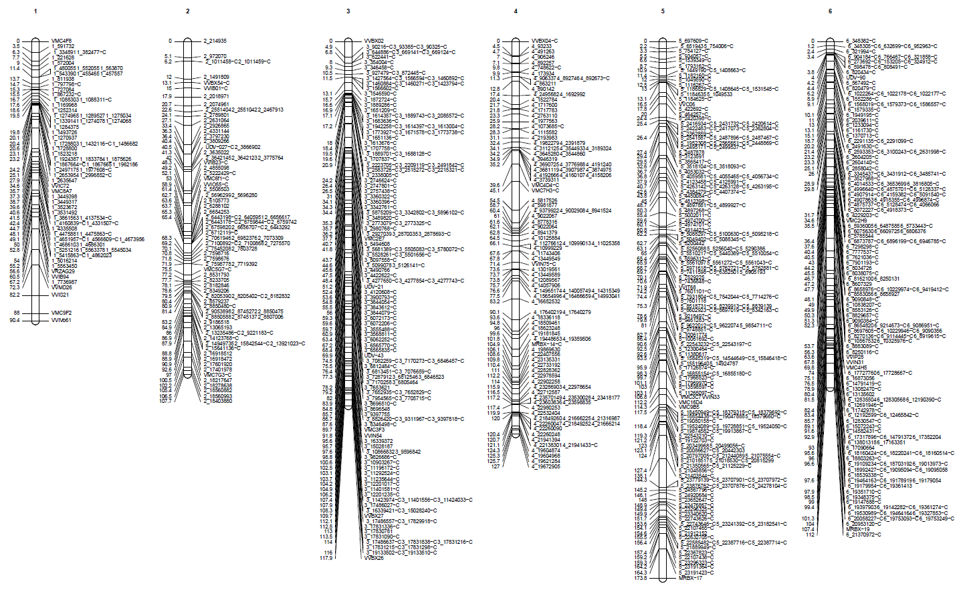
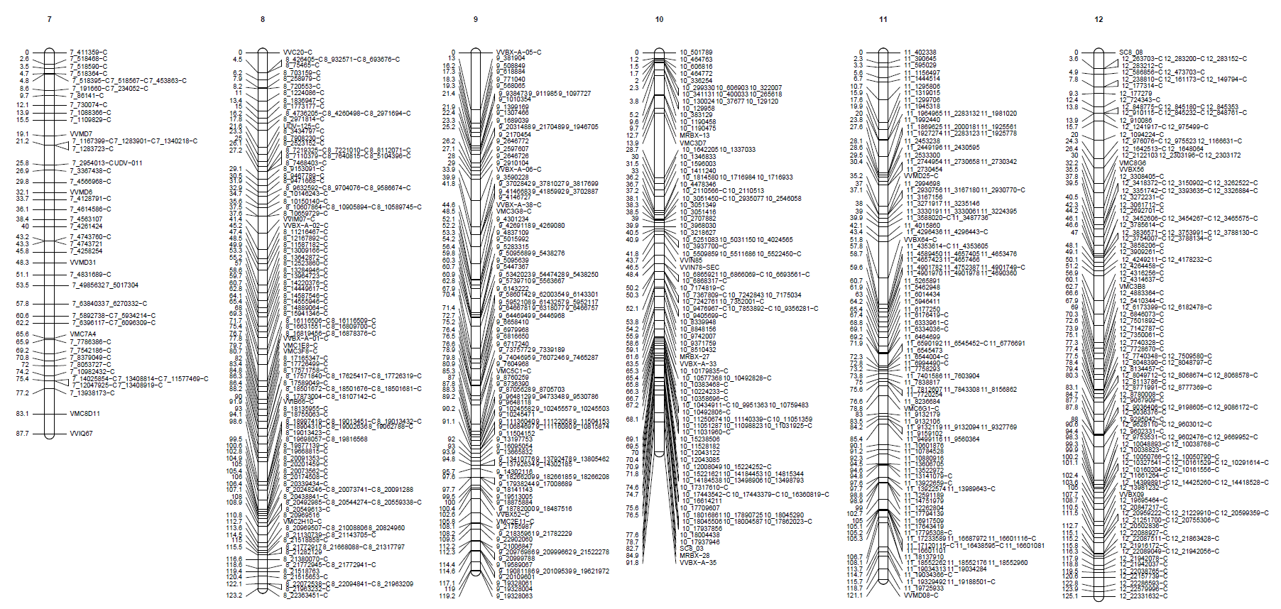
1
2
3
4
5
6
7
8
9
10
11
12
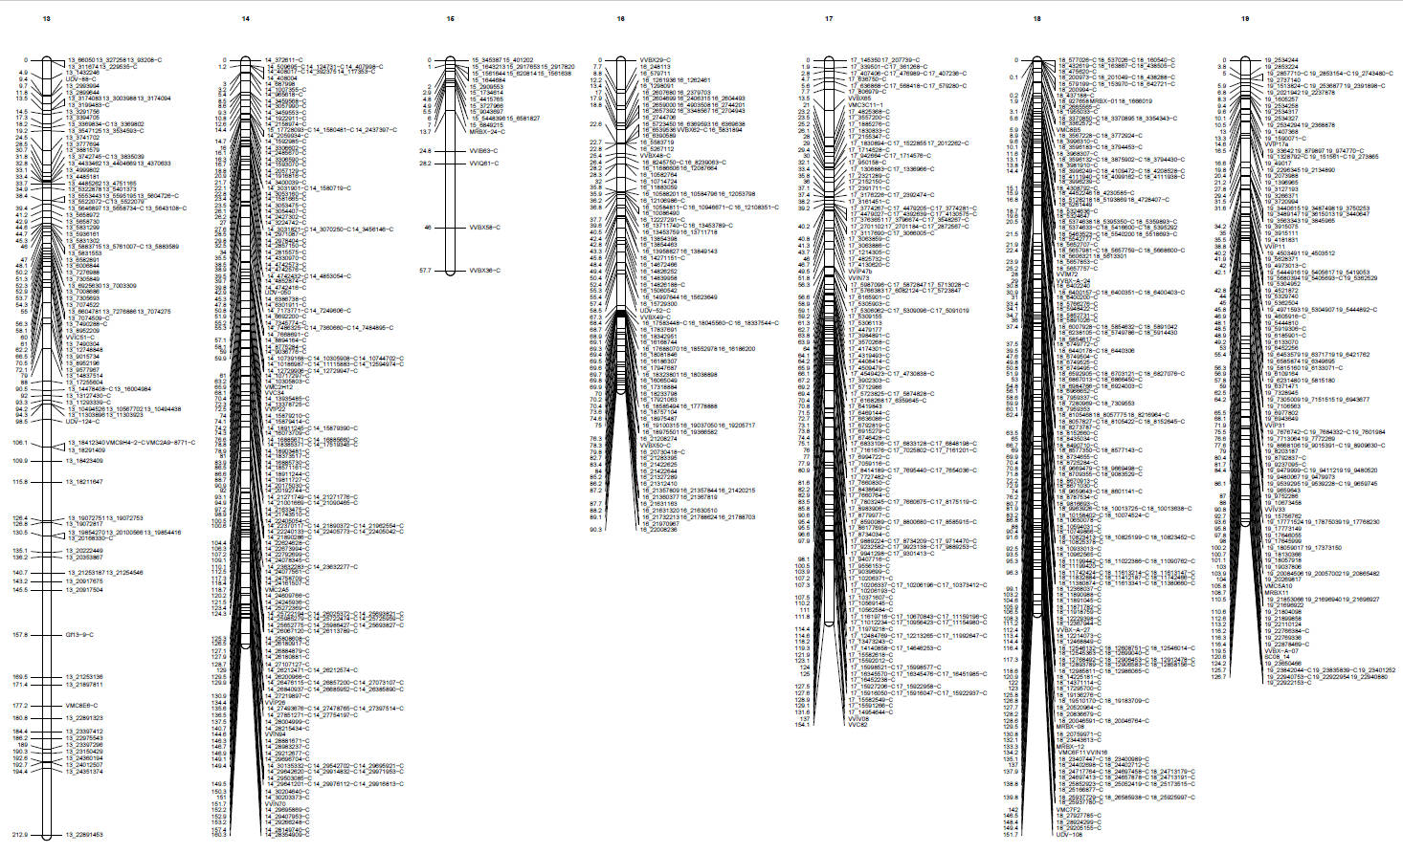
13
14
15
16
17
18
19
Fig. S2 Maternal genetic map related to VRH8771
Each linkage group is represented by a bar with the genetic positions on the left side and marker names on the right side

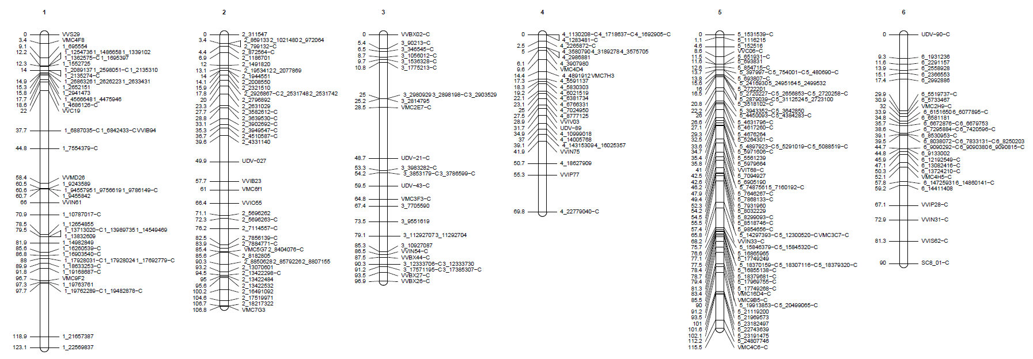
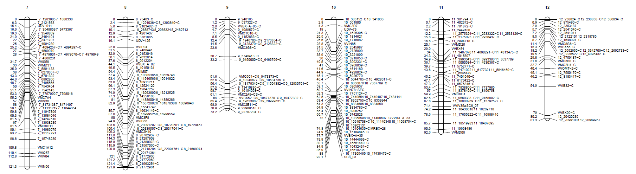
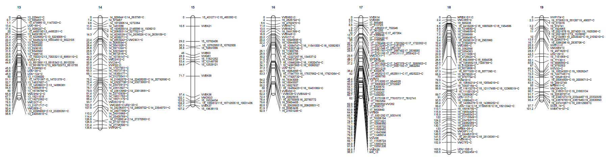
1
2
3
4
5
6
7
8
9
10
11
12
13
14
15
16
17
18
19
Fig. S3 Paternal genetic map related to CS
Each linkage group is represented by a bar with the genetic positions on the left side and marker names on the right side.

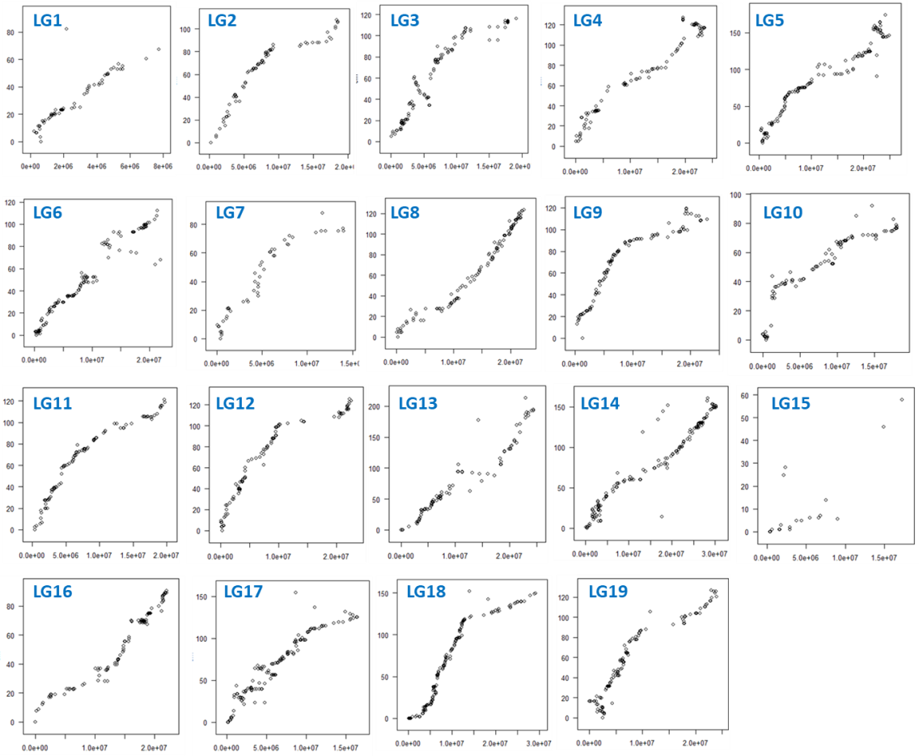
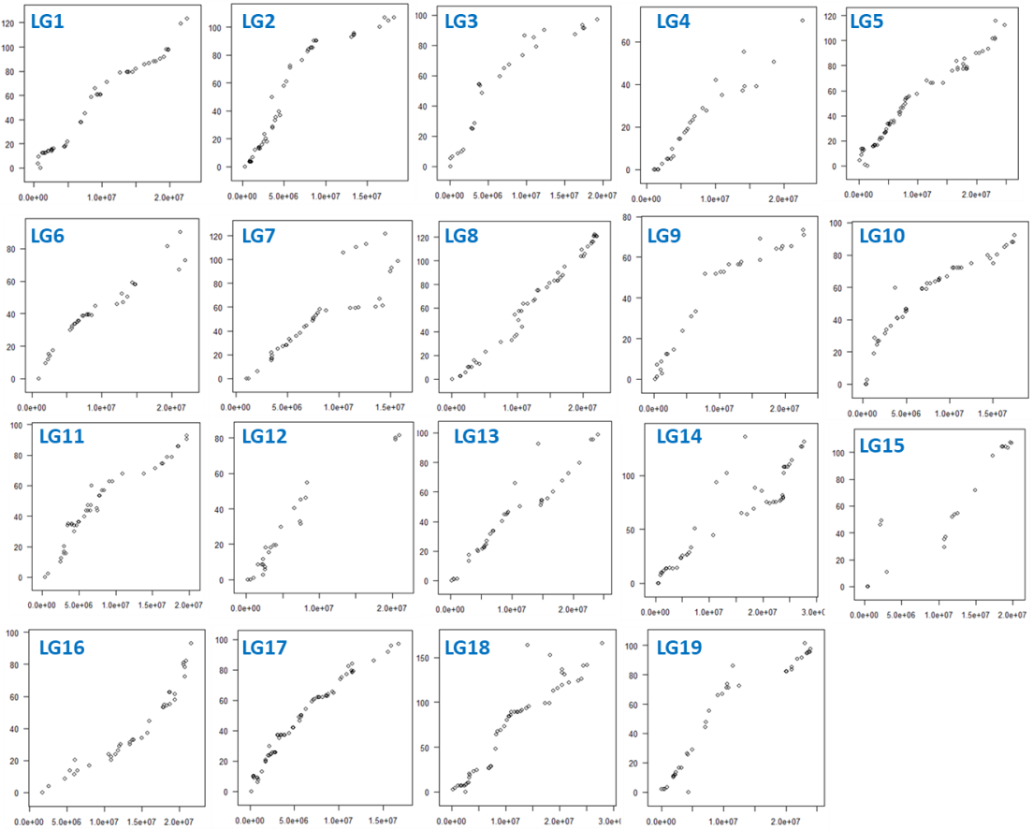
A
Fig. S4 Variation of genetic distance depending on physical distance on the VRH8771 (A) and CS (B) genetic maps
The y axis represents the genetic distances (in cM) and the x axis represents the physical distances (in bp) related to the V. vinifera cv ‘Pinot Noir’ (PN40024). Each plot represents an individual linkage group

B

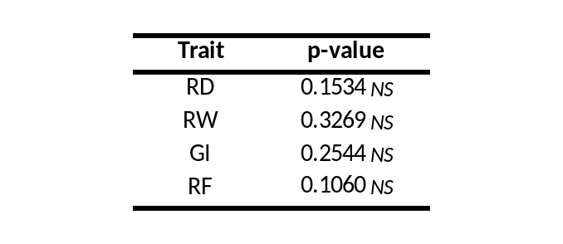
Table S4 Statistical analyzes comparing data between 2010-2011 and 2011-2012 experiments
The non-parametric Wilcoxon signed-rank test was performed on four traits: root system development (RD), weight of the roots (RW), nematode reproduction factor (RF) and gall index (GI)
Signif.codes: 0 ‘***’ 0.001 ‘**’ 0.01 ‘*’ 0.05 ‘.’ 0.1 - NS, not significant
Fig. S5 Principal component analysis (PCA) of the 35 F1 individuals tested in 2010-2011 and 2011-2012 experiments with root system development (RD), root weight (RW), nematode reproduction factor (RF) and gall index (GI).
The two major principal components that accounted for 94.25 % of the variance have been plotted. The individual factor map is represented: the BC1 individuals were assigned to two groups according to the year of experiment: 2010-2011 in blue and 2011-2012 in gray.
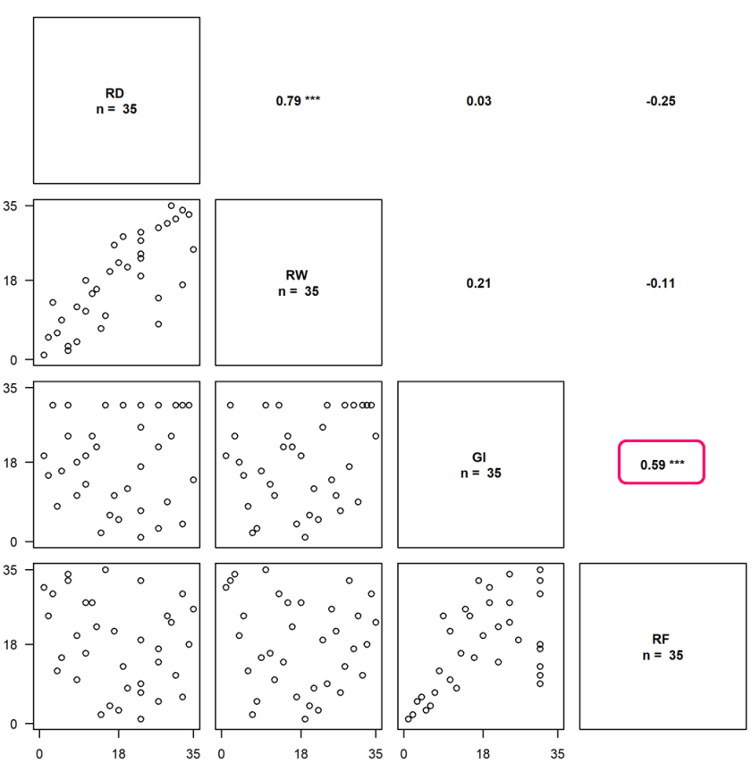
Fig. S6 Correlation matrix of the four criteria (RD – RW – RF – GI) scored in 2010-2011 and 2011-2012 experiments in response to X. index
Spearman correlations were performed. The positive and significant correlation between RF and GI was surrounded on the graph. Signif.codes: 0 ‘***’ 0.001 ‘**’ 0.01 ‘*’ 0.05 ‘.’ 0.1

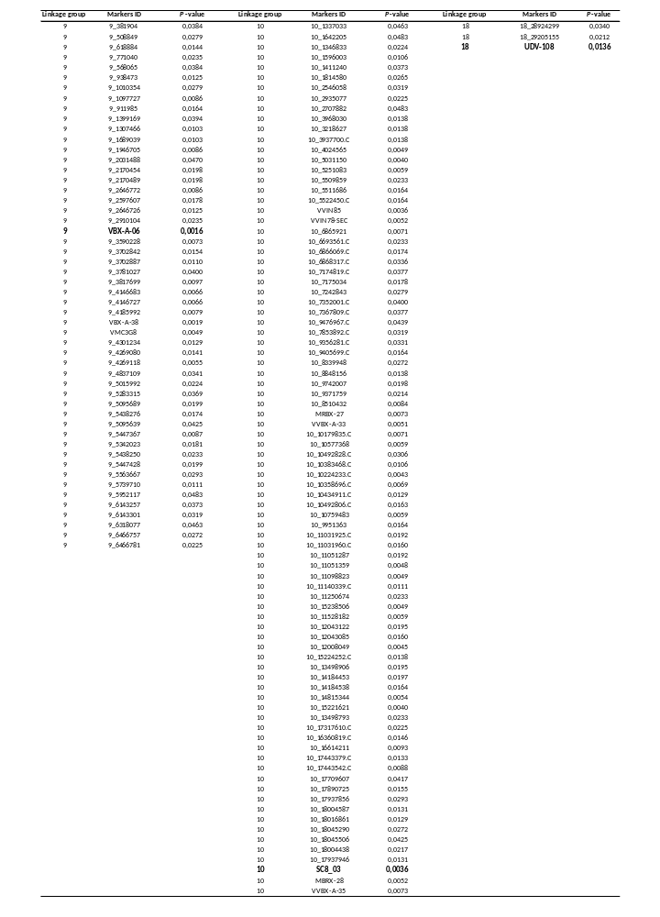
Table S5 Results of the proportion test performed on 60 BC1 individuals in response to X. index
The results presented are related to the markers for which the p-values are statistically significant at α = 5%

